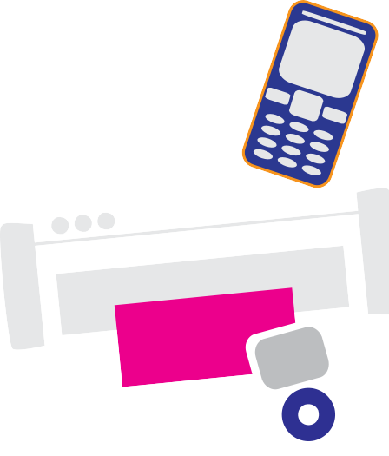

Recycling Event

Items accepted:
- Computers / Laptops / Servers
- Mouse / Keyboard / Cable(s) / Cord(s)
- Televisions / Monitors
- DVD Players / VHS Players
- Cassette Players
- Video Game Consoles / Accessories
- Speakers / Stereo equipment
- Phones / Cell Phones / Answering Machines
- Wire / Cabling / Printed Circuit Boards
- Microwave Ovens / Toasters
- Printers / Fax Machines
- Rechargeable and Alkaline Batteries
- Chargers
*We shred all hard drives so no one can access your personal information

Insert event information here

Insert contact information here

