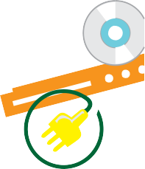
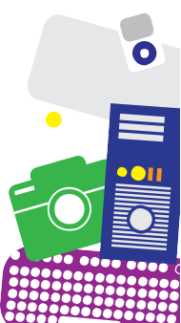
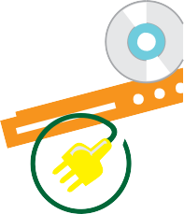
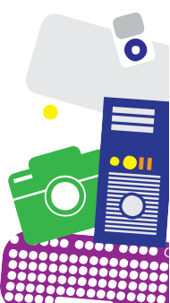
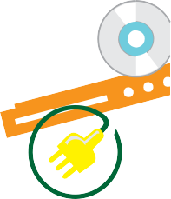
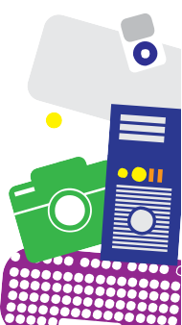

The city of is organizing a FREE E-Waste collection and recycling event. Bring your old electronics for proper recycling and prevent contamination.
The electronics contain toxic components that should not be thrown away in the trash.
The collection event is scheduled from to on at
The city of is organizing a FREE E-Waste collection and recycling event. Bring your old electronics for proper recycling and prevent contamination.
The electronics contain toxic components that should not be thrown away in the trash.
The collection event is scheduled from to on at
The city of is organizing a FREE E-Waste collection and recycling event. Bring your old electronics for proper recycling and prevent contamination.
The electronics contain toxic components that should not be thrown away in the trash.
The collection event is scheduled from to on at

For more information, Call or visit:
Items accepted:
- Computers / Laptops / Servers
- Mouse / Keyboard / Cable(s) / Cord(s)
- Televisions / Monitors
- DVD Players / VHS Players
- Cassette Players
- Video Game Consoles / Accessories
- Speakers / Stereo Equipment
- Phones / Cell Phones / Answering Machines
- Wire / Cabling / Printed Circuit Boards
- Microwave Ovens / Toasters
- Printers / Fax Machines
- Rechargeable and Alkaline Batteries
- Chargers
*We shred all hard drives so no one can access your personal information

For more information, Call or visit:
Items accepted:
- Computers / Laptops / Servers
- Mouse / Keyboard / Cable(s) / Cord(s)
- Televisions / Monitors
- DVD Players / VHS Players
- Cassette Players
- Video Game Consoles / Accessories
- Speakers / Stereo Equipment
- Phones / Cell Phones / Answering Machines
- Wire / Cabling / Printed Circuit Boards
- Microwave Ovens / Toasters
- Printers / Fax Machines
- Rechargeable and Alkaline Batteries
- Chargers
*We shred all hard drives so no one can access your personal information

For more information, Call or visit:
Items accepted:
- Computers / Laptops / Servers
- Mouse / Keyboard / Cable(s) / Cord(s)
- Televisions / Monitors
- DVD Players / VHS Players
- Cassette Players
- Video Game Consoles / Accessories
- Speakers / Stereo Equipment
- Phones / Cell Phones / Answering Machines
- Wire / Cabling / Printed Circuit Boards
- Microwave Ovens / Toasters
- Printers / Fax Machines
- Rechargeable and Alkaline Batteries
- Chargers
*We shred all hard drives so no one can access your personal information

