ADEQ’S Earth Day PLEDGE
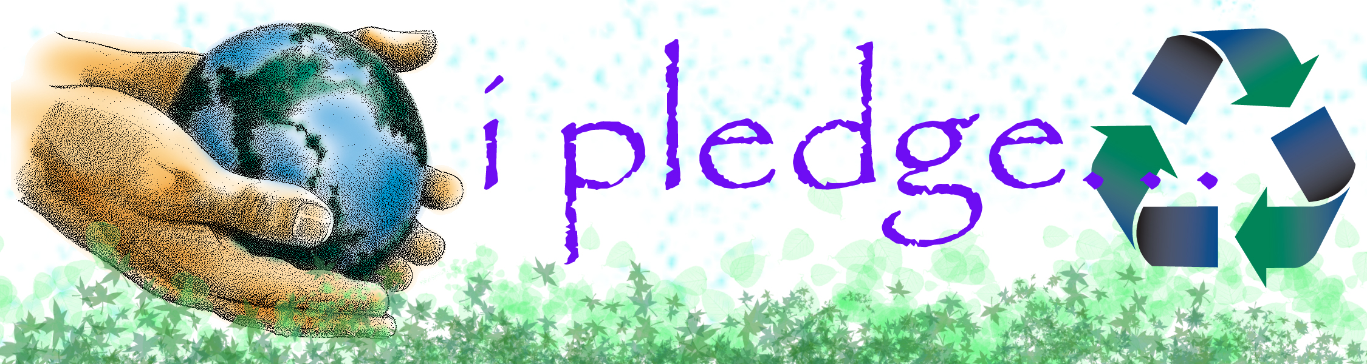

I pledge to make Earth Day every day and do all I can to help
the environment.

I pledge to recycle, conserve energy and save water to protect Arizona’s natural resources.

I pledge to help my family and school learn how they can help
the environment and prevent pollution for a cleaner and
healthier Arizona.

I pledge to do one or more of the following:

- Recycle cans and bottles instead of throwing them away.

- Turn off the water while brushing my teeth and ask my family to do the same.

- Turn off the lights when leaving a room.

- Donate old usable toys and books instead of throwing

them away.
- Ride a bike or walk when I can.

- Never litter and dispose of my trash properly.

- Turn off the TV and electronic games when they are not

in use.

Student’s First Name Date

School

